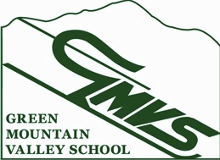

NVC U14 Qualifier Slalom
NVC U14 Race, M/W SL February 16, 2014

Contact: Cheryl Skovran
Email: cskovran@gmvs.org
This will be a 2 run combined race.
Eligibility: NVC/USSA/VARA U14 Racers
Registration: 7:00am – 8:30am in the GMVS Clubhouse
Racers should station themselves in the Mt. Ellen base lodge
Entry Fee: $20 - lift ticket included
Entry: Coaches’ list
Race Trail: Inverness
Lift: 8:00am Inverness Lift/ 8:30am GMVS Poma
Course Inspection: 8:15 – 9:15am
Start time first run: 9:30am
Awards: In front of the GMVS Ski Club 30 minutes after the race.
Parent tickets: available at registration
Team Captain’s meeting: 8:00am on deck of the GMVS Clubhouse

USSA/VARA/NVC rules apply
Vermont state law requires use of the safety bar.

Check fact sheet prior to Sunday 2/16/2014 for any changes on www.vara.org.

