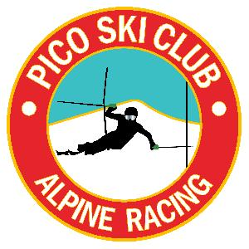

Harry Chapin Memorial
VARA Open
Pico Mountain
2-19-18 - Monday

Trail: B-Slope
Lift: LPT
Start Time: 9:30am

Membership: All participants must be an alpine competitor member of USSA and have a current state affiliation. VARA member athletes receive first priority

Registration: Registration will be online only at Adminskiracing.com. Registration will close on Sunday, 2-18-18 at 09:31AM or when the race field equals 180, whichever occurs first. Pulls are due by Sunday, February 18th at 09:31AM. (online processing fees are not refundable). If the race closes due to entries a wait list will be started. Please email babbittcarolyn1@gmail.com

If an athlete is present without a coach he/she must find representation from another coach in order to participate in the race.

Bibs and Tickets: All athlete bibs and tickets will be picked up at registration located at the Andrea Mead Lawrence Lodge adjacent to Pico Ski Club. Registration will open from 7:30am-8:30am.

Coaches Tickets: Will be available at the Team Captains Meeting at 8:15am downstairs of Pico Ski Club.

Bibs: All bibs will be collected at the finish area after the athletes second run. A missing bib fee will be assessed of $100 and will be billed to the racer.

Day Storage for visiting athletes and families: All belongings should be stored at the Pico Base Lodge or the Slope Side Loft. The AML is for registration only and the Pico Ski Club is a private facility - Please respect the memberships privacy.

PROGRAM of EVENTS to be posted at a later date!

