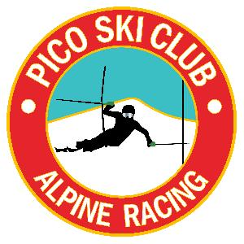

VARA/MVC U12 GS
Pico Mountain
1-28-2018

Race Slope: B-Slope

Start Time: 9:30am

Entry Fee: $30.00 - Online registration only - adminskiracing.com

Registration: Opens at 7:30am in the Andrea Mead Lodge (adjacent to the ski club). The AML is not to be used as a storage facility. Please use the Pico Base Lodge.

Membership: All athletes and coaches must be current members of USSA and VARA

Coaches: Tickets can be picked up at Captains Meeting

Captains Meeting: Will be held in the lower level of the ski club at 8:15am - all athletes must be represented!

ENTRIES: All entries with the exception of Petitioned Athletes must be registered online through adminskiracing.com by 9:00am on Saturday, January 27th.

Running orders: Per council rule, for this event, the race will be run in the following order: U12 BOYS, U12 girls. The running order of racers in each gender shall be determined by random draw. Run 2 will be as follows: boys then girls in reverse order, with first run DNFs running in their same place (but in reverse order) for the second run.

Awards: Award Ceremony time will be announced at the end of the race, approximately 30 minutes after completion of the race. Awards will be given out in front of the deck at Pico Ski Club.
- Awards will be given to the top ten in each gender determined by best combined time.
- The Doberman Boot award goes to the top four (4) boys and /or girls with the lowest score by team. Team scores will be calculated as follows: Each gender should be ranked separately. Each team’s top 4 place points based on best combined time (regardless of gender) are then added together. The team with the lowest score wins. For example, a team with the 1st, 5th, and 8th boys and the 2nd, 3rd, and 4th girls would have a team score of 11. In the event of a tie, the team with the best single place would win.

PROGRAM of EVENTS to be posted at a later date!

