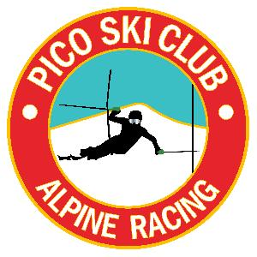


VARA - George Tormey Series

Pico Mountain
3-9-19- Saturday

Trail: B-Slope

Membership: All ATHLETES AND COACHES must be USSA members. USSA is the governing body.

Registration: Registration will be online only at Adminskiracing.com. Registration will close on Friday, 3-8-19 at 09:31AM or when the race field equals 175, whichever occurs first. Pulls are due by Firday, 3-8-19 by 12:00pm. (online processing fees are not refundable).

Bibs and Tickets: All athlete bibs and coach tickets will be picked up at registration located at the Andrea Mead Lawrence Lodge adjacent to Pico Ski Club. Registration will open at 7:30am.

Coaches Tickets: Will be available at the Team Captains Meeting at 8:00am downstairs of Pico Ski Club. -- ALL COACHES - we are in need of your help. If you could help pull fencing after the last competitor and place in the tree line! Thank you.

Bibs: All bibs will be collected at the finish area after the athletes second run. A missing bib fee will be assessed of $100 and will be billed to the racer.

Parent Tickets: Will be sold at Registration only. $45.00 cash or check only.

Day Storage for visiting athletes and families: All belongings should be stored at the Pico Base Lodge or the Slope Side Loft. The AML is for registration only and the Pico Ski Club is a private facility - Please respect the memberships privacy.

PROGRAM of EVENTS
Saturday, March 9, 2019

Registration - 7:30am-8:30am

Coaches Meeting - 8:00am - lower level of the ski club.
Tickets for coaches will be at this meeting

Inspection 8:15am to 9:00am

Forerunners: 9:20am

Run 1 9:30am
Run 2: TBD

TD: Chris Clarke
COR: Barry Cupoli

Awards 15 to 30 min after the completion of the last racer and after the fence is rolled in front of the Ski Club Deck.

