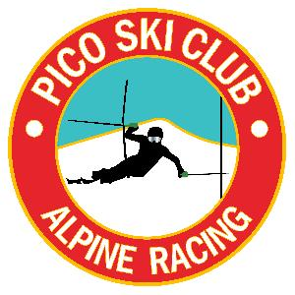

VARA U14 SL
Pico Mountain
01-12-20

Race Slope: B-Slope

Start Time: 9:30am

Entry Fee: $40.00 -

Registration: Opens at 7:30am in the Andrea Mead Lodge (adjacent to the ski club). The AML is not to be used as a storage facility. Please use the Pico Base Lodge.

Membership: All athletes and coaches must be current members of USSA and VARA

Coaches: Tickets can be picked up at Captains Meeting

Captains Meeting: Will be held in the lower level of the ski club at 8:15am - all athletes must be represented!

ENTRIES: will be made online via www.adminskiracing.com

Parent Tickets can be purchased at Registration for $45.00 Cash or Check payable to Pico Ski Racing.

Running orders will be determined by Random Draw. 2nd Run start order will be reverse bib order. The girl with bib number 1 will start last in the second run as will the boy with the first bib number for the boys will run last for the boys in the second run. Girls will run before boys in each run.

Awards: Award Ceremony time will be announced at the end of the race, approximately 30 minutes after the race completion. Awards will be given out in front of the deck at Pico Ski Club.

Medals for the top ten boy and girls overall combined results and the Bean Pot will be given to the winning team of the day.

Proposed Schedule of the Day
7:30-8:30 Registration in AML building
8:00 Lift for race crew and jury
8:15 Team Capt meeting in basement of Pico Ski Club
8:15 Lift for athletes and coaches
8:15-9:15 Inspection for SLrace
9:30 Start SL Race
Remaining schedule to be determined at Capt meeting

