

VARA MVC U14 GS at Okemo Resort
Official Race Announcement

Date: 03/06/21
Event(s): GS
Parent Tickets: Not Available
Venue: Wardance

Registration Information

Entry Procedure: Register online at Admin Ski Racing
Registrations: $45 race fee. Registrations will be open from 5pm 2/27/21 and will close at 5pm 3/3/21. There will be no late registrations.
Coach registration: All attending coaches must also register on adminskiraing.com for contact tracing and communication purposes.
All registered athletes and coaches must complete a COVID Screening questionnaire 48-24 hours prior to the event on adminskiracing to be eligible to be in the venue.

Lifts: To access the Wardance races athlete will need to ride the A-B Quads from the ClockTower base and then the Blackridge triple. A- B Quad will be open from 800am.

Proposed Program: (TBC at TCM)
Women’s Race- Inspection 8:30am-9:00am
Start 930am
Men’s Race- Inspection 11:15am-11:45am
Start 1215pm

- There will be no Announcer or Scoreboard. Times will be available via LiveTiming.com
- Wardance Cameras will stream live throughout the day: Weblink: https://www.go2omara.com/

Assigned Team Meeting Areas:
Current VT guidelines require participants to be in groups of 25 or less that do not interact with each other throughout the day. Each team (club) will have designated team area at the top of the course. This area is for athletes and coaches only. Participants will need to remain in their team area until called to the start for inspection (as a team) or for their start.

Inspection: Inspection will be in groups by team, please wait in your designated team area until Start Personal signal that you may begin inspection. The whole team must inspect together, teams should stay apart two gates minimum at all times. Only one inspection will be allowed.

Team Captains’ Information
First TCM Date: 03/05/2021
First TCM Time: 6:00 PM EST
First TCM Meeting Link & Call-In Information, will be emailed to coaches after registration closes and posted on the MVC Whats App group.
Bib Pickup/Registration Information: Each designated Team Captain will meet the Covid Coordinator at the tent besides the Okemo Competition Center between 7:30 - 8:30am to verify that all required Covid-19 requirements have been met and to return waivers. A Team packet with tickets for each club and coaches must be picked-up at this time.

- All athletes and coaches must register online before the team captains meeting. There will be no same day registrations.
- Team packet collection marked with Red X on map.
- Athletes will not be able to get dressed inside the lodges.
- Athletes to wear their assigned MVC bib.

Should any member of your team become symptomatic during the day, it must be reported to COVID Coordinator and the person shall be removed from the venue. Team Captains must have a plan to get this person home or to health care.

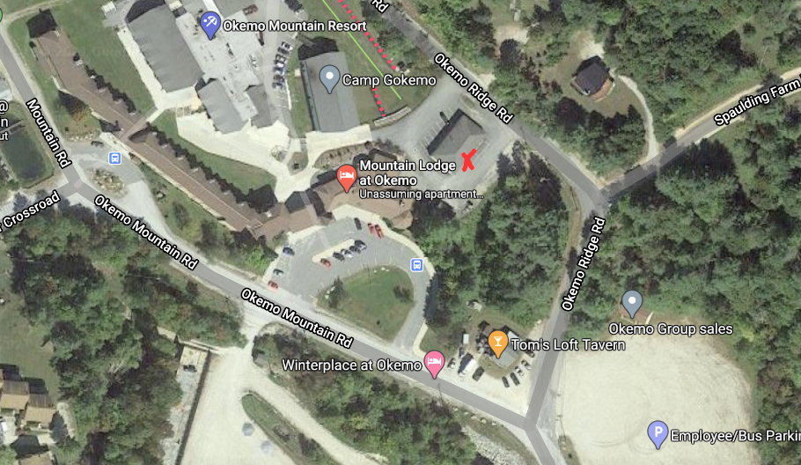

Race Organizing Committee
Technical Delegate: Greg Hadley
Chief of Race: Ali Bombardier
Race Administrator/Covid Coordinator: Eric Friedlander
Contact Information: eric.friedlander@vailresorts.com, 802-228-1483

Official announcements will be via MVC WhatsApp group chat

COVID-19 Guidelines & Information

Daily Symptom/Health Check: Must be done on admin ski racing for athletes and coaches and coaches will have to attest for all athletes.

Vermont COVID-19 Guidelines:
Due to COVID-19, many states have travel restrictions in place for visiting out-of-staters. Please closely review the state and/or resort guidelines listed below to determine if you are eligible to travel to Vermont. It’s incredibly difficult to verify if visitors to the state/resort meet the requirements, therefore it is imperative that you follow the published guidelines.
- Link to State Published Guidelines: https://accd.vermont.gov/news/update-new-work-safe-additions-be-smart-stay-safe-order#sports-and-organized-sports
- State Travel Restrictions/Requirements: https://accd.vermont.gov/covid-19/restart/cross-state-travel
- State Mask Policies: Masks are required in all public places.

Okemo Mountain COVID-19 Guidelines:

- Link to Okemo Mountain COVID-19 Guidelines: https://www.okemo.com/explore-the-resort/about-the-resort/winter-experience.aspx

Okemo Mountain Mask Policy: Face coverings will be required to access the mountain, in all indoor spaces, in any line, on chairlifts, and whenever you are unable to maintain physical distance. Face coverings should follow CDC guidelines.
Lodge Access Information: Masks are required. Personal items will not be allowed to be stored in the base lodges (no boot/gear bags). Restrooms and food-to-go items will be available. Plan to minimize your indoor warm-up time. Lodge must not exceed 50% max capacity requirements. Reservations are required.
Lift Line/Lift Riding Information: To allow for physical distancing on our chairlifts, we will only be seating related parties (guests skiing or riding together) or: two singles on opposite sides of a four/six-person lift, and one single on a three-person lift. The safety bar must be down per VT State Law.
Parking/Parking Lot Information: Parking will be in the main lot.

Additional Information

Awards: *Per the COVID-19 Alpine Domestic Competitions Guidance, in-person awards ceremonies are currently prohibited. Awards can be collected by the Team captain from registration at the end of the event.
SPECTATORS: No Spectators are allowed at the Race Arena and as per US Ski and Snowboard and Mountain policy. This includes at the finish. The area at the finish of Wardance and the load of Blackridge chair needs to be kept clear at all times. Personal items will not be allowed to be stored in the base lodges (no boot/gear bags).
- There are no parent tickets available this season. If parents wish to ski Okemo this day we recommend making a reservation in advance as weekend reservations may fill up early.

Okemo Mountain has clear social distance and mask use signage. Please respect the resort's rules on these policies. Masks MUST be worn properly while not racing. Okemo Mountain will be auditing athletes not wearing masks in the lift lines and will use this to evaluate future races.

Please review U.S. Ski & Snowboard’s COVID-19 Alpine Domestic Competitions Guidance

