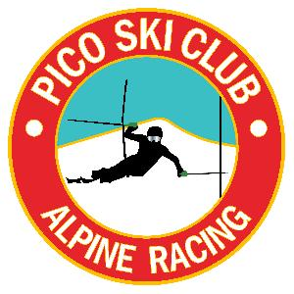

Harry Chapin Memorial
VARA Open SL-Men’s Only
Pico Mountain
2-6-22 Sunday
Trail: B-Slope
Time: 9:30am
Entry Fee: $65.00

Membership: All ATHLETES AND COACHES must be USSA and VARA members.

Registration: Registration will be online only at Adminskiracing.com. Registration will close on Friday, 2-04-22 at 09:00PM Pulls are due by Friday by 12:00pm. (online processing fees are not refundable).

Coaches Registration: All coaches must register for this race through adminskiracing.

Bibs and Tickets: All Bibs and Tickets (Including Coaches Tickets) will be packaged by team and available at 7:45am in the AML. Coaches must return all unused bibs and tickets to the Timing Tower by 9:00am.

Bibs: All bibs will be collected at the finish area after the athletes second run. A missing bib fee will be assessed of $100 and will be billed to the racer.

Parent Tickets: Will be sold at Registration only until 8:45am $65.00 cash or check only - Checks payable to Pico Ski Racing.

The AML is for registration only and the Pico Ski Club is a private facility - Please respect the memberships privacy.

MASKS are required in all indoor facilities.

PROGRAM of EVENTS
Sunday, February 6, 2022

Registration - Bibs and Tickets will be picked up by Team Captains between 7:45am-8:45am - Team Captains - Please return all unused bibs and tickets by 9:00am.

Coaches Meeting -will be held via zoom at 4:30pm Saturday, Feb 5th. The link will be emailed to coaches that have registered, as well as, put out on What’sApp.

Inspection 8:30am to 9:15am

Forerunners: 9:20am

Run 1 9:30am -

Second Run: TBD during Run 1

DQ Reporting - DQ’s will be posted via What’sApp and announced after the completion of the run.

Awards 15 to 30 min after the completion of the last racer and after the fence is rolled in front of the Ski Club Deck.

