TGFS RACE MARCH 18, 2015
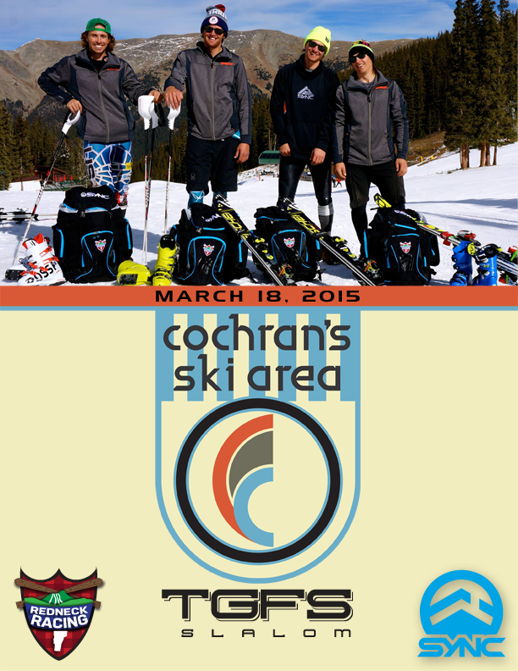
Come join Redneck racing team members and some US Ski team members, college racers and others for an awesome day of ski racing at Cochran's.

Less then a week to register for TGFS Race at Cochran's !!!
You can register by emailing me your name, date of birth and USSA number and pay at registration or go online to www.alpinereg.com.
Please if the entry fee is a hardship for you email me. Cochran's believes that if you want to race you should be able to and not let money get in the way !!!!!!
This race is a fundraiser for Cochran's so that we can do the repairs that we need to through the summer. But please we want you to come race. It is a great race and a fun day !!!!
Grand Raffle:
Sync Performance GS Suit and 2 coaching sessions with Rednecks and Jimmy Cochran.
$5 for arms length of tickets
For your entry fee you will have a great day of racing, a terrific t shirt, a yummy BBQ and support an amazing little ski area that does big things for hundreds and hundreds of local kids and their families. Thank you !!!!
TGFS Race at Cochran's Ski Area.
Slalom M/F U16, U18, U21, & senior
Tuesday March 18, 2015
Cochran's Ski Area
910 Cochran Rd.
Richmond, VT 05477
More information contact: Laura Farrell
jlfarrell0@gmail.com
802-291-1348

Come join Redneck racing team members and some US Ski team members, college racers and others for an awesome day of ski racing at Cochran's. For your entry fee you will have a great day of racing, a terrific t shirt and a yummy BBQ.
Please enter on alpinereg.com
Registration opens at: 730am
Lifts: 800am
Course inspection: 800am to 845am
Race start: 900am (women first)
Yummy BBQ: all afternoon
Hope to see you on March 18th 2015
Thanks, Laura

