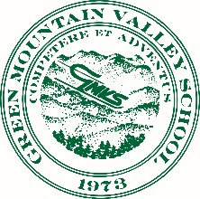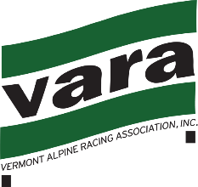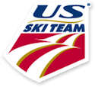

Race Announcement
VARA Open Early Season SL- USSA Scored U16, 19, 21

Date: Tuesday December 13, 2016. USSA Points List 717 Men and Ladies Races
Ski Area: Sugarbush- Mt Ellen Trail: Lower Inverness Homologation: U870/08/12
Registration: ONLINE ONLY www.AdminSkiRacing.com Event#68271
Fee: $65/$55 for GMVS passholder. Registration/Pull Deadline:1800hrs Mon12/12/16
Note: Athletes and Coaches must have current USSA & VARA membership

Race Administration: BB Baker Technical Delegate: Topher Harlow
Green Mountain Valley School USSA# 4898888
271 Moulton Rd Chief of Race: Jere Brophy
Waitsfield, VT 05673 USSA# 4638854
802.496.2150

Race Day Check In 0700-0800hrs. Upstairs GMVS Training Center
Team Captain’s Meeting: 0745 Bottom of T-bar. All athletes MUST be represented by a valid coach.
T-Bar open for Athletes 0800hrs
First Run Inspection 0815-0845
First Run: 0900hrs

****The mountain is closed except for this race.
Please note that this is a T-Bar length SL

Join GMVS in donating the following lightly used items for refugees in Vermont:
WINTER CLOTHING DRIVE

-Jackets
-Ski Pants
-Hats
-Gloves/Mittens
-Scarves/Neckies
-Winter Footwear
- NEW Socks

Boxes for donations will be located at race registration.

Thank you!!!

