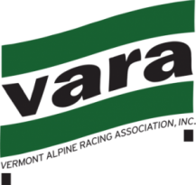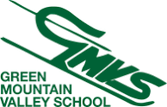
Race Announcement
NVC U12 Dual Stubbie SL - Sunday, Feb. 3, 2019
NVC/VARA/USS Men’s and Women’s Races (not scored)
Ski Area: Sugarbush - Mt. Ellen Trail: Lower Inverness
Registration: Coaches List
Fee: $25 (please pay online in advance of event) https://adminskiracing.com/
Race Administrator: Kirsten Andreae (kirsten@gmvs.org)
Technical Delegate: TBA
Running Order: Random Draw
Race Day Schedule:
07:00-08:00 Coaches sign-in and Bib Pick-up - Upstairs GMVS Clubhouse
08:15 Team Captains’ Meeting - GMVS Clubhouse – Downstair’s Coaches Room.
08:30 Lift Open to Athletes & Coaches
08:45-09:45 Inspection
10:00 1st Racers on Course
12:30 2nd Run (approx.)
Awards: 15-20 minutes after last racers / Medals to Top 10 M & W

Notes: Teams, please submit a list of attending coaches and athletes in advance (this will allow for more rapid coach check-in and distribution of lift access RFIDs and bibs). Athletes and Coaches must have current and applicable USSA and VARA membership. All athletes must be properly represented at the TCM. All Jr. Coaches must be accompanied/supervised by a fully certified Coach.
Notes:
- Bibs will be bundled and distributed to COACHES at sign-in
- Parents and athletes, please use the Mt. Ellen Baselodge
- Please ‘rack’ your skis or they may be removed
- Parent viewing is from the finish area.
- In accordance with VARA rules, parents may not be in the start area
- Discounted Parent Lift Tickets Available at Mount Ellen Ticket Window?

