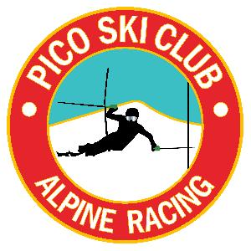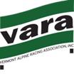

VARA U14 SHOOT OUT
Pico Mountain
02/25/2018

Race Slope: B-Slope

Start Time: 9:30am

Entry Fee: $50.00 - payable at registration cash or check payable to Pico Ski Club.

Registration: Opens at 7:30am in the Andrea Mead Lodge (adjacent to the ski club). The AML is not to be used as a storage facility. Please use the Pico Base Lodge.

Membership: All athletes and coaches must be current members of USSA and VARA

Coaches: Tickets can be picked up at Captains Meeting

Captains Meeting: Will be held in the lower level of the ski club at 8:15am - all athletes must be represented!

ENTRIES: All entries will come from Council Lists.

Running orders/Seeding: The field will be seeded in order of ranking from each Council. The VARA Executive Director will execute the draw to determine the council running order. The running order will remain the same for each run.

Awards: Award Ceremony time will be announced at the end of the race, approximately 30 minutes after completion of the race. Awards will be given out in front of the deck at Pico Ski Club.

A total of 23 boys and 23 girls will be selected to go to states. Selection will be based on the best single place point of 3 possible scores, including 1st run, 2nd run and combined results. Ties will be broken by next best run. Time differential will be used in case of 3 way tie, if still a tie then all the tied competitors will be selected.

Medals for the top ten boy and girls overall combined results.

Proposed Schedule of the Day
7:30-8:30 Registration in AML building
8:00 Lift for race crew and jury
8:15 Team Capt meeting in basement of Pico Ski Club
8:15 Lift for athletes and coaches
8:15-9:15 Inspection for GS race
9:30 Start GS Race
11:00-11:30 SL course sets (girls course/boys course)
11:30-12:15 Inspection
12:30 Start SL race

