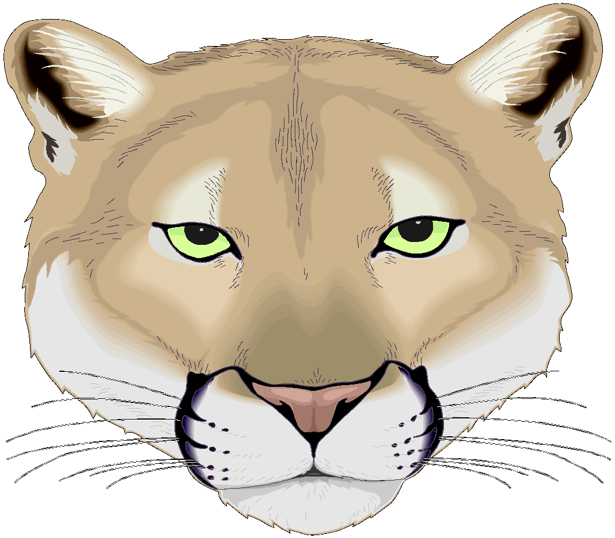
11th Annual Cochran’s Cougar Cup Challenge
WHERE: Cochrans Ski Area- Richmond, VT
WHEN: Monday January 15, 2018
SCHOOLS: CHS, Stowe, NCU, Essex, LI, Rice, BFA, Harwood, Lamoille
LIMIT: 20 athletes per school
EVENT: 2 runs SL (first run girls skiers right, boys skiers left. 2nd run switch courses)
REGISTRATION: Registration in Cochrans Lodge: 9:00-10:00am
Inspection: 9:00-9:45
` ` 10am Race Start
2nd Run will be immediately after first run
FEE: $ 15.00 per skier to Cochrans Ski Area
$25.00 Timing fee per school to Cochrans ski club
2 coaches tickets per team

AWARDS: Awards will be given to the top 5 males and top 5 female after second run. Overall winning team with a combined boys and girls top 4 will take the Cougar Cup back to their school for 1 year.

RUNNING ORDERS: Please Email Julie Sloan (Julie.sloan@cesuvt.org) OR David Marlow (david.marlow@cesuvt.org)
Must be in by Friday January 12, 2018 by 12:00 PM
**Send orders in excel format last, first, school**

LATE ENTRIES WILL BE SEEDED AT THE END OF THE RUNNING ORDER!

PLEASE INFORM YOUR SKIERS
BIBS MUST BE SHOWN ENTIRE TIME ON THE HILL AND UNSAFE SKIING WILL RESULT IN DSQ FROM THE RACE

QUESTIONS ? Julie Sloan Cell Ph. (802) 734-3099 A.D. Dave Marlow Ph. (802) 858-1774

BUS DRIVERS: Please drop off athletes up top and then park in lower lot.

ATHLETES: Please respect the lodge and clean up after, there is no cleaning crew at Cochran’s!

