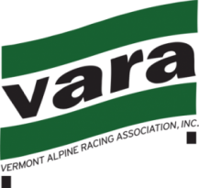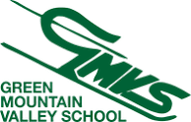

Race Announcement
VARA Open GS - Sunday, Jan. 6 2019
USS National Points List 10 2019 - Men’s and Women’s Races

Ski Area: Sugarbush - Mt. Ellen Trail: Inverness
Homologation: 9598/09/10 (FIS)
Registration: Online Only https://adminskiracing.com/
Fee: $65 / $10 late fee from 12/31 Registration/Pull Deadline: 23:59hrs 1/04/19
Race Administrator: Kirsten Andreae (kirsten@gmvs.org)
Technical Delegate: Cort Jones
Chief of Race: TBA
Notes: Teams please submit a list of attending coaches in advance (this will allow for more rapid coach check-in and distribution of lift access RFIDs). Athletes and Coaches must have current and applicable USSA and VARA membership. All athletes must be properly represented at the TCM. Bibs will be bundled and distributed to COACHES at sign-in. All Jr. Coaches must be accompanied/supervised by a fully certified Coach.
Race Day Schedule:
07:00-08:00 Coaches sign-in and Bib Pick-up - Upstairs GMVS Clubhouse
07:45 Team Captains’ Meeting - GMVS Clubhouse – Downstairs Coaches Room.
08:00 Lift Open to Athletes & Coaches
08:30-09:15 1st Run Inspection (s)
09:30 1st Racer on Course (Women, followed immediately by Men)
11:30-12:15 2nd Run Inspection (time approximation)
12:30 2nd Run (time approximation)
Awards: 15 minutes after last racer

