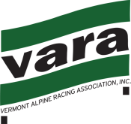
February 17, 2014
Green Mountain Valley School is pleased to announce the following schedule for the 2014 MVP Health Care VARA Mens U16 State Championships to be held at the Kelly Brush Race Arena at Sugarbush USA.

Sunday February 23, 2013 Slalom Day
7:00am Registration Opens Upstairs GMVS Training Center
7:30am Lift for Jury Inverness
8:00am Lift for Athletes Inverness
8:30am Registration Closes
8:30am Coaches Meeting Finish Area
8:30am 1st run Inspection Open Kelly Brush Race Arena
9:15am 1st run Inspection Closes Kelly Brush Race Arena
9:20am 1st run Forerunners Kelly Brush Race Arena
9:30am 1st Racer- 1st Run Kelly Brush Race Arena
11:30am 2nd run Inspection Opens Kelly Brush Race Arena
12:15pm 2nd run Inspection Closes Kelly Brush Race Arena
12:20pm 2nd run Forerunners Kelly Brush Race Arena
12:30pm 1st Racer- 2nd Run Kelly Brush Race Arena

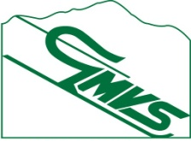
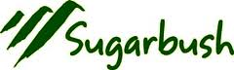

Monday February 24, 2013 Giant Slalom Day
7:00am Registration Opens Upstairs GMVS Training Center
7:30am Lift for Jury Inverness
8:00am Lift for Athletes Inverness
8:30am Registration Closes
8:30am Coaches Meeting Finish Area
8:30am 1st run Inspection Open Kelly Brush Race Arena
9:15am 1st run Inspection Closes Kelly Brush Race Arena
9:20am 1st run Forerunners Kelly Brush Race Arena
9:30am 1st Racer- 1st Run Kelly Brush Race Arena
11:30am 2nd run Inspection Opens Kelly Brush Race Arena
12:15pm 2nd run Inspection Closes Kelly Brush Race Arena
12:20pm 2nd run Forerunners Kelly Brush Race Arena
12:30pm 1st Racer- 2nd Run Kelly Brush Race Arena
3:00pm Awards Upstairs deck- GMVS Training Center

Please Note: Schedule and location are subject to change. Please understand that we are subject to weather conditions and other Force Majeure conditions which may necessitate the modification of this planned event.

Entry Fees:

SL only - $55 cash or check only. Please make checks payable to GMVS.
GS only - $60 cash or check only.

Both Events - $115 cash or check only.

Racers must check in at registration daily to receive a lift ticket.

Bib Return: Bibs must be returned following each race.

Following Sunday’s race, all bibs must be returned. A $50 fee will be assessed for all unreturned/lost bibs.

Parent /Family Tickets: Tickets will be available at the Mount Ellen ticket window. Pricing is $46 for Mount Ellen.

