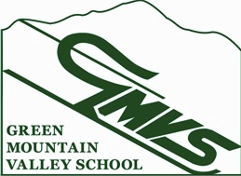

NVC U12 Race, M/W Paneled Slalom
Kelly Brush Race Arena, Sugarbush – Mt. Ellen
February 22, 2015

Contact: Cheryl Skovran
Email: cskovran@gmvs.org
Eligibility: NVC/USSA/VARA U12 Racers
Registration: 7:30am – 8:30am in the GMVS Clubhouse
*Racers should station themselves in the Mt. Ellen baselodge. Please store your belongings properly and make room for others enjoying the mountain that day.*
Running order will be random draw. 2nd run is reversed bib order
Entry Fee: $20 - lift ticket included (cash or check only)
Entry: Coaches’ list
Race Trail: Inverness
Lift: Inverness Chair-opens to racers at 8:00am-Poma opens at 8:30am
Course Inspection: 8:15am – 9:15am
Start time first run: 9:30am
Awards: In front of the GMVS Ski Club 30 minutes after the race.
Parent tickets: available at the Mt. Ellen ticket window
Team Captain’s meeting: 8:30am in the finish.

USSA/VARA/NVC rules apply
Vermont state law requires use of the safety bar.

Check fact sheet prior to Sunday 2/22/2015 for any changes on www.vara.org.

