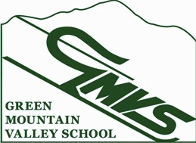

NVC U12 Qualifier
M/W Stubbie SL January 19, 2014

Contact: Cheryl Skovran
Email: cskovran@gmvs.org
Eligibility: NVC VARA U12 Racers
Registration: 7:30 – 8:30 am in the GMVS Clubhouse
Racers should station themselves in the Mt. Ellen base lodge
Running order will be random draw. 2nd run is reversed bib order
Entry Fee: $10 - lift ticket included
Entry: Coaches’ list
Race Trail: Inverness
Lift: GMVS T Bar: opens to racers at 8:30am
Course Inspection: 8:30 – 9:30am
Start time first run: 10:00am
Awards: In the GMVS Ski Club approximately 30 minutes after the race.
Parent tickets: available at Mount Ellen ticket office for $46
Team Captain’s meeting: 8:15 am in front of the lower timing building

USSA/VARA/NVC rules apply.

Vermont state law requires use of the safety bar.

Check fact sheet prior to Sunday 1/19/2014 for any changes on www.vara.org.

