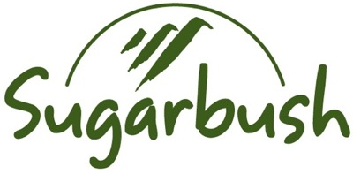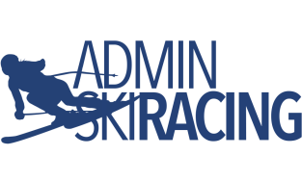

Race Announcement
Admin Ski Racing U16 VT State Championships March 1-2, 2019
NAT Points List 14 2019 - Women’s GS & SL Races

Ski Area: Sugarbush - Mt. Ellen Trail(s): Brambles / Brambles-Inverness
Homologations: FIS 12885+6/11/18
Registration: Online Only https://adminskiracing.com
Fee: $65 ea. + $10 late fee after 2/22 Registration/Pull Deadline: 2/27/19 - 23:59hrs
Race Administrator: Kirsten Andreae (kirsten@gmvs.org)
Technical Delegate: BB Baker
Chief of Race: Jere Brophy
Notes: Teams please submit a list of attending coaches in advance (this will allow for more rapid coach check-in and distribution of lift access RFIDs). Athletes and Coaches must have current and applicable USSA and VARA membership. All athletes must be legally represented at the TCM.
Race Day Schedule:
07:00-08:00 Registration Open- Upstairs GMVS Clubhouse
07:45 Team Captains’ Meeting - GMVS Coach’s Room.
08:00 Lift Open to Athletes & Coaches
08:30-09:15 1st Run Inspection (s)
09:30 1st Racer on Course
11:00-11:45 2nd Run Inspection (time approximation)
12:00 2nd Run (time approximation)
13:30 Awards Party

